ENTRY FORM FOR Sunday JUNE 11, 2017 CONNEMARA SHOW ONLY

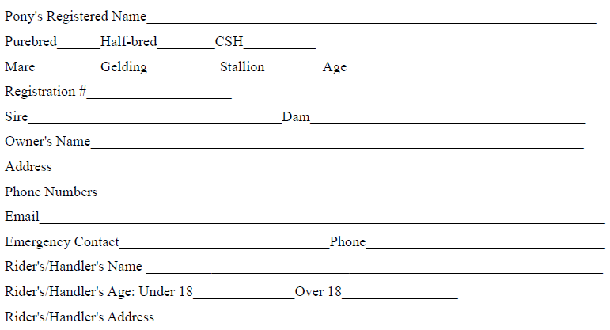PRE-ENTRY DEADLINE Monday JUNE 5 (You may add classes the day of the show; pre-entry is required to ensure stabling assignments and head-count for the social event). Send this completed Entry Form, Coggins, Chatt Hills Liability Release and Payment made out to “ACPS Region 4” and sent to Show Secretary:
Penny Morse, 324 East Davis Bridge Rd., Villa Rica, Georgia 30180, Email: designonpenny@yahoo.com
Class # | CLASS NAME | FEE
ENTRY FEE TOTAL | Pre-registration is $12/class. Day of show is $15/class, if no pre-entry was sent.
STABLING | 1 NIGHT$30.00 or 2 NIGHTS $50.00
SHAVINGS | $8.00 A BAG
RV/CAMPER | $50.00 PER NIGHT
GROUND FEE | $20.00 NON STALLED HORSES
SATURDAY evening Region 4 SOCIAL | $15.00 PER PERSON (includes meal)
TOTAL DUE | TOTAL PAYABLE TO ACPS REGION IV
Chattahoochee Hills liability release form http://chatthillseventing.com/wp-content/uploads/2017/01/Chattahoochee-Hills-Eventing-2017-Release-Form.pdf .
Print, sign, and include this with your registration for the Connemara Show on Sunday

